# Session 11 Assignment 3

Twitter data analysis using Flume

Login to twitter apps – <https://apps.twitter.com>

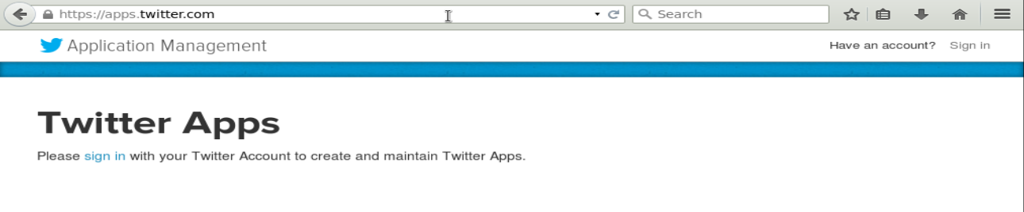

Login with your account details.

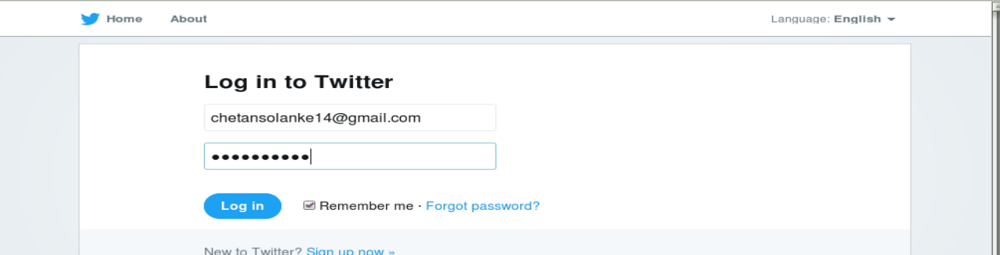

Click on “Create New App”

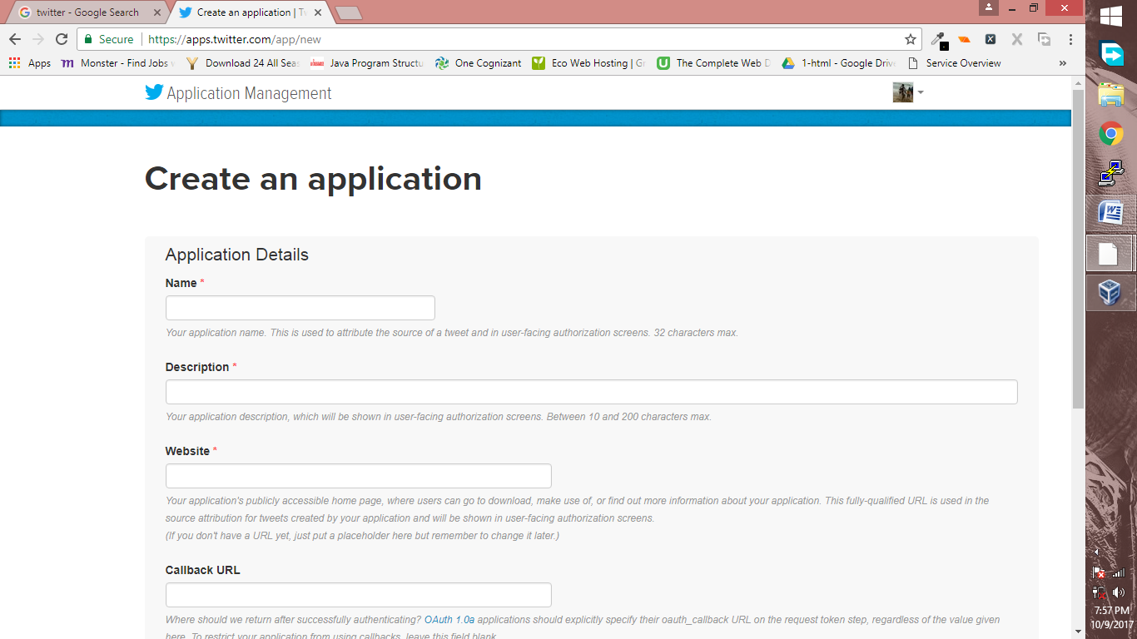

Enter the following details, accept the agreement and click on “Click on Twitter Application”

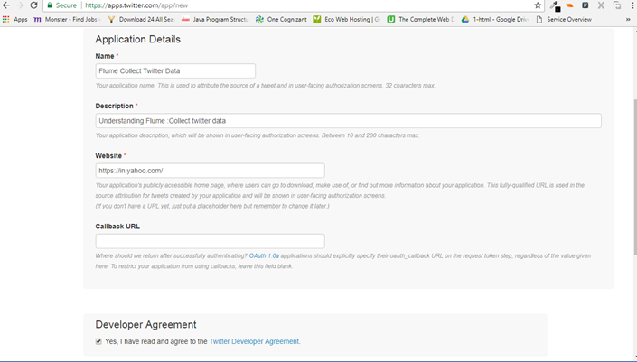

Now, the app is created. Click on “Keys and Access tokens”

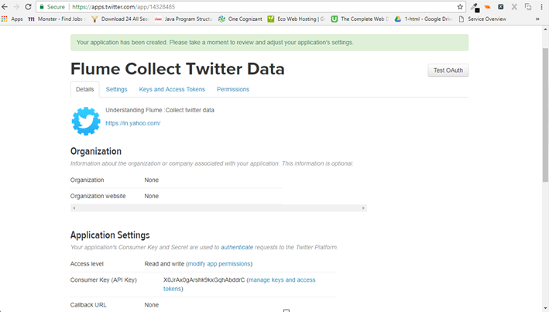

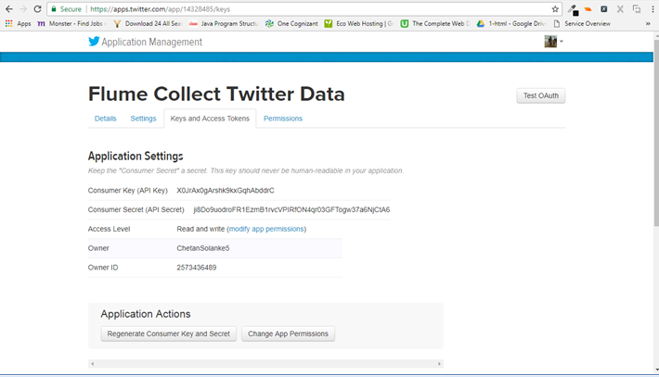

Scroll down and click on Create my access token.

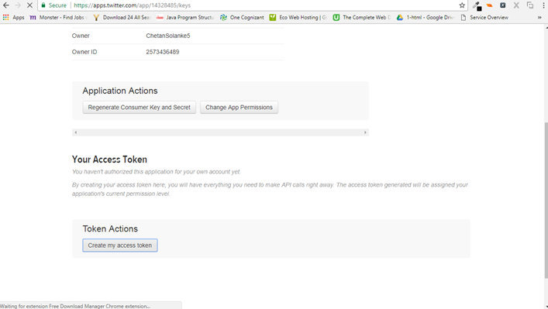

Create a file under $FLUME_HOME/conf

In this we will specify the takens and security keys generated above.

Flume.conf

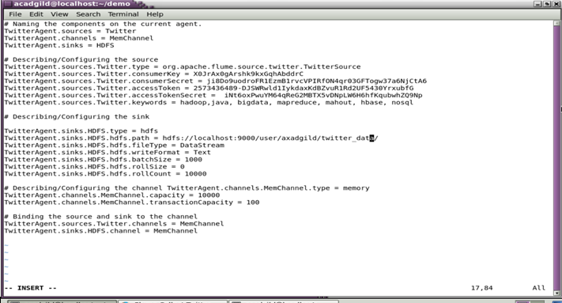

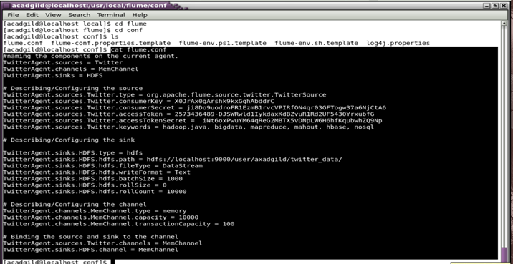

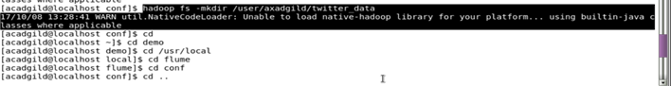

Invoke flume agent.

./flume-ng agent -n TwitterAgent -f $FLUME_HOME/conf/flume.conf

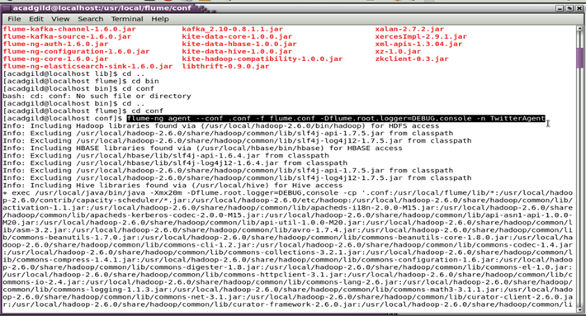

Check the output.

